

**BDT WEEK 1**

**NAME:**  **DATE:**

**ROLL NUMBER:** **BRANCH:** CSD-C

**PROBLEM STATEMENT:**

Oracle virtual VM and Cloudera installation.

**Website:**

Oracle VM VirtualBox

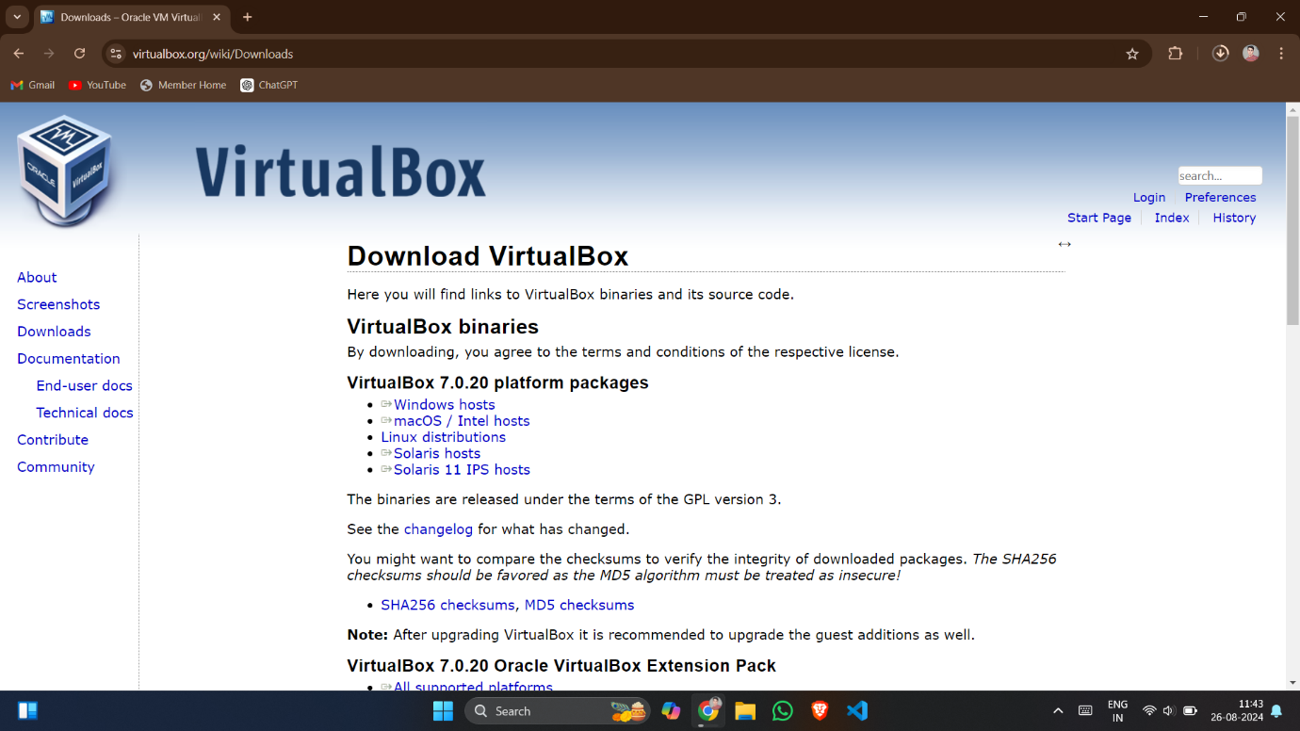

**Steps:**

1. Install Oracle VM VirtualBox and Cloudera from the official websites.
2. Now install the VM VirtualBox in the system and also extract all cloudera files into the respective local drive.

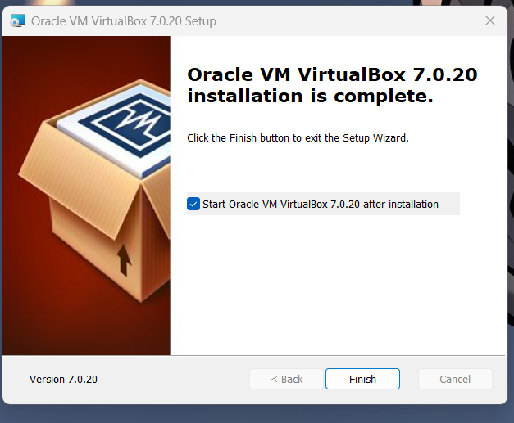

1. Now open the VM VirtualBox and import the cloudera file(15kb) and make changes in the OS while importing.

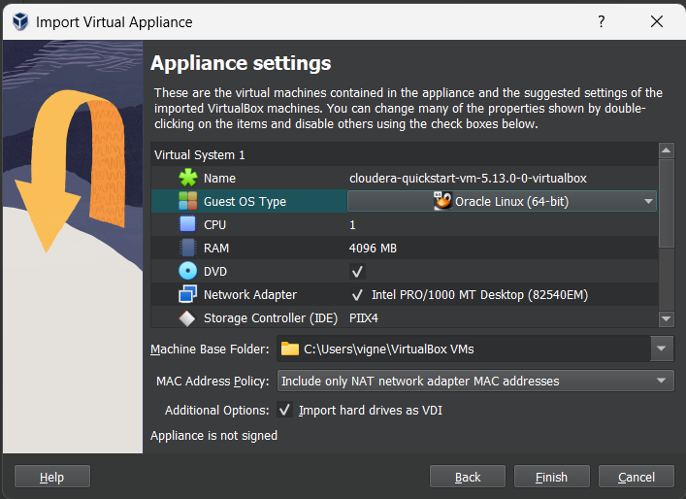

1. Now after the importing of the cloudera is completed, open the cloudera in the VM VirtualBox.

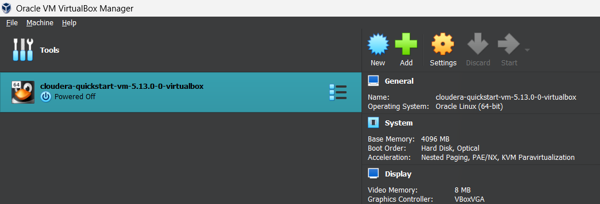

1. As the cloudera is running on the console, you can perform all the Hadoop operations in the cloudera terminal.

**Final Output Console:**

